Audio-Visual Entrainment: Dental Studies
David Siever¹, Edmonton, Alberta, Canada

Abstract: A great deal of temporo-mandibular joint dysfunction and myofascial pain dysfunction is activated in relation to anxiety and fear responses to challenging tasks, self-criticism and daily stresses. AVE, like passive meditation, appears to effectively alleviate these symptoms.

Historical Background

The first few studies of visual entrainment (VE) used a device called the Brain Wave Synchronizer. The seminal hypnosis study by Kroger and Schneider in 1959 prompted more research along hypnosis lines. Shortly thereafter VE was used as an analgesic for gastro-intestinal surgery, where it was found that over 90% of patients entered useable levels of trance induction prior to surgery (Sadove, 1961). The Sadove study caught the interest of the dental profession, which was awakening to the role of anxiety in temporo-mandibular joint (TMJ) and myofascial pain dysfunction and during dental procedures.

Dental Studies

VE was shown to reliably “drive” dental patients into a hypnotic induction during dental work in a short period of time, if the VE frequency was set near the dominant natural alpha frequency of the patient (Margolis, 1966). Margolis placed the “synchronizer” near the patient during a dental procedure. He noted several positive effects.

- VE reduced the amount of anesthetic used.
- In some cases, hypno-anesthesia could be used exclusively.
- Anesthesia could be terminated immediately following surgery.
- VE produced no depressing physiologic side-effects.
- VE made post-hypnotic anesthesia possible.
- VE controlled gagging.
- VE reduced fear and anxiety in the dental situation.

TMJ dysfunction is an affliction that affects many people. In order to understand the scope of the VE studies with TMJ, it is important to have a deeper understanding of TMJ dysfunction and myofascial pain dysfunction.

Theories of TMJ Dysfunction

Two theories exist as to explain the origins of bruxism, TMJ dysfunction and myofascial pain dysfunction (MPD), a condition involving severe pain in facial regions. The tooth-muscle theory ascertains that disharmony in occlusion produces altered proprioceptive information that activates the occlusal pattern generator which activates the masticatory (jaw-closing) muscles, which in turn grind down the dentition until a satisfactory occlusion is reached (Manns, et.al., 1981, Moulton, 1966, Laskin, 1969). Certainly, many people can recall a time when a poorly made dental filling or orthotic has activated this response, quickly resulting in jaw tension and pain.

The psychophysiologic theory implies that emotional factors such as stress and anxiety manifest in increased muscle tension (Manns, et.al., 1981, Laskin, 1969, & Moulton 1966) and increased perception of pain (Christensen, 1981). It has also been shown that all people show high levels of masseter tension during initial exposures to a stimulus-response task (Yemm, 1971). Further, it has been shown that masseter muscle activity increases during challenging tasks, primarily when the subjects made errors (Yemm, 1969). The Yemm study implies a direct relationship between self-critical thoughts and tension. Controls show a trend towards relaxation with repeated exposures to the task, whereas those suffering with TMJ dysfunction show an initial relaxation phase during the first few exposures followed by a marked increase in masseter muscle tension with repeated exposures to stimulus-response tasks. This performance anxiety was termed TMJ personality by Yemm. Anxiety and stress, and the consequent impact on trait arousal are a major part of a variety of dental disorders. (Spielberger, et.al.1970, Rugh & Solberg, 1975, Yemm, 1971, Weinstein, et. al., 1971). Some additional disorders relating to stress are gingivitis, osteoporosis of the alveolar bone in animals, alterations in the chemical composition of saliva, and ulcerative oral legions in dogs (Giddon, 1966). A further investigation of those with gingivitis, revealed reduced salivary output, increased gingival arterial dilation and increased sublingual temperature in response to stress.

Rugh and Solberg devised a study where the participants used a small data-logging EMG on the masseter to measure nighttime or nocturnal bruxism. Hard clenches activated the recorder. This device could log several days worth of data, which was displayed as the amount of time of bruxing, in brux seconds/hour. Figure 1 shows a typical example of the relationship between life stressors and jaw tension, in this case, in a young lady.

Figure 1 Stressful Life Events and Nocturnal Bruxism

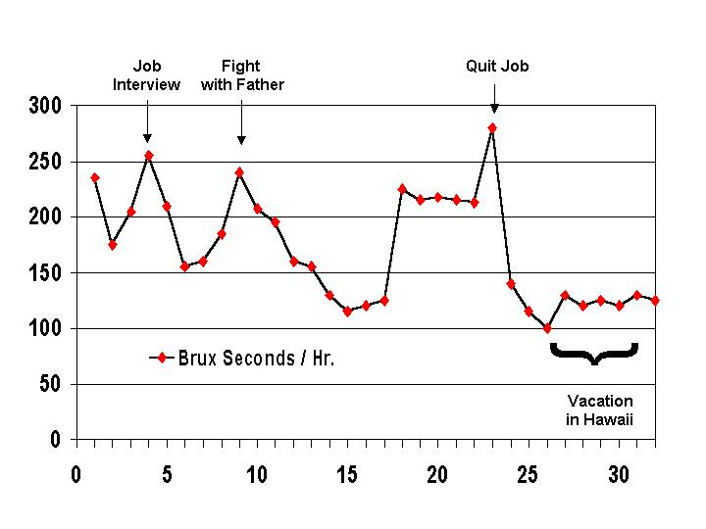

When experienced Transcendental Meditators were exposed to photic stimulation near natural alpha frequencies, they reported subjective experiences similar to their usual experience during meditation (Williams & West, 1975). A comparison of various strategies aimed at reducing trait anxiety have shown that passive meditation techniques such as TM are considerably more effective than other strategies such as progressive relaxation or concentration meditation (Eppley & Abrams, 1989). This connection between the ability to entrain a brain wave pattern similar to that of meditators, combined with the subjective meditative experience of AVE, and the fact that meditation produces a pronounced reduction in trait anxiety, may explain why AVE produces such striking reductions in anxiety as measured in AVE studies. The next study demonstrates this point.

Audio entrainment (AE) has shown promise as a singular therapeutic modality for treating tension and pain (Manns, Miralles, & Adrian, 1981). In this study, people suffering with myofascial pain and TMJ dysfunction were split into two groups -- group A, those with symptoms for less than one year (n=14), and group B, those with symptoms for longer than one year (n=19). They received 15-minute sessions of auditory entrainment (AE) consisting of isochronic, pure (evenly pulsed sine wave) tones, followed by 15 minutes of EMG feedback and concluding with 15 minutes of AE and EMG feedback combined, for an average of 14 sessions. The study clearly shows greater reductions in EMG activity during AE. Table 1 shows the reduction in MPD/TMJ symptoms following treatment.

Table 1 TMJ Symptoms Following Audio Entrainment and EMG Feedback

Symptom | Group A (n=14) |  | Group B (n= 19)
 | Participants with symptoms (%) |  | Participants with symptoms (%)
 | Pre Tx | Post Tx | Pre Tx | Post Tx
Bruxism | 100 | 7 | 100 | 32
Emotional tension | 100 | 14 | 100 | 21
Muscle fatigue | 93 | 0 | 74 | 21
Insomnia | 57 | 0 | 53 | 0
Dizziness | 21 | 0 | 53 | 0
Headache | 93 | 0 | 74 | 0
TMJ Pain | 64 | 0 | 47 | 0
Masticatory muscle pain | 71 | 0 | 58 | 9
Neck muscle pain | 79 | 9 | 79 | 26
Otalgia | 79 | 9 | 32 | 17
Mastoid process pain | 43 | 0 | 16 | 0
Articular clicking | 50 | 29 | 68 | 54
Mandibular deviation | 79 | 36 | 84 | 56
Restricted opening | 43 | 0 | 16 | 0

A study involving 10 people (Figure 2) with long histories of TMJ dysfunction was conducted to see whether they would relax to a guided imagery exercise. Just prior to the guided imagery, they were given the suggestion of entering deep relaxation by the end of the guided imagery (Thomas & Siever, 1988). With this expectation in mind, all of the subjects showed bracing or dysponesis as indicated by a drop in hand temperature and a short fall in masseter muscle (EMG) tension followed by a considerable increase in tension until the “relaxing” guided imagery ended (at which time they did begin to relax moderately). Interestingly, all members subjectively reported feeling very relaxed, even though they all had tensed up somewhat. The group then underwent 10 minutes of 10 Hz AVE from a DAVID1 system. Within five minutes masseter muscle tension became very relaxed and hand temperature increased, signs of sympathetic deactivation and parasympathetic activation – the meditation response.

Figure 2. Masseter Muscle Tension and Hand Temperature during a Guided Imagery and AVE

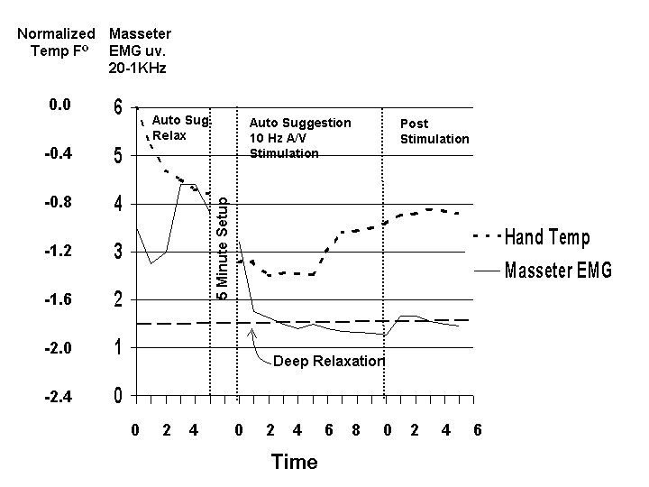

Dental patients often suffer anxiety before and during dental appointments (Lazarus, 1966, Dewitt, 1966, Corah & Pantera, 1968). Of all the dental procedures, root canal (endodontic) therapy is the most feared (Morse 1993). Audio-analgesia using white noise and/or music (as produced by a commercially marketed unit) has been shown to effectively increase pain threshold and pain tolerance during a dental procedure (Gardner & Licklider, 1959; Gardner, Licklider, & Weisz, 1960; Schermer, 1960; Monsey, 1960; Sidney, 1962; Morosko & Simmons, 1966).

A study implementing AVE to reduce anxiety during a root canal procedure has also shown promising results (Morse 1993). This study involved three groups of 10 subjects. The groups consisted of a group receiving 10 Hz AVE, a group receiving 10 Hz AVE plus an alpha relaxation tape (developed by Shealy) simultaneously, and a control group (Figure 3). The study confirmed that the part of a root canal procedure that produces the greatest anxiety is the Novocaine™ injection, pushing average heart rate up to 107 bpm. The group using AVE had an average heart rate of 93 bpm, while the group that was further dissociated (AVE and music), had an average heart rate of 84 bpm.

Figure 3. Heart Rate during a Root Canal Procedure
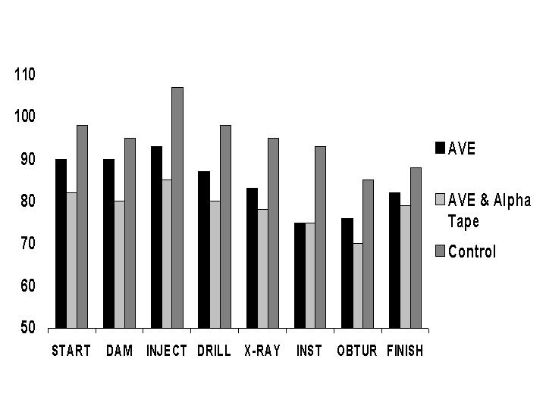

AVE may settle down jaw tension through muscle spindle de-activation (Siever, 1992). Muscle spindles regulate body tone and posture as well as facilitate the myotatic reflex (McClintic, 1978). They are fibers that are directly attached to either the muscle fibers (extrafusal fibers) or to the filaments of tendons. As shown in Figure 4, the spindle consists of two parts, the nuclear chain fiber and the nuclear-bag fiber. Spiral sensory endings called afferent neurons wrap around the central portion of both fibers. The fibers receive gamma efferent neurons. These serve to set the “tone” or sensitivity of the spindle.

Figure 4. Muscle Spindle
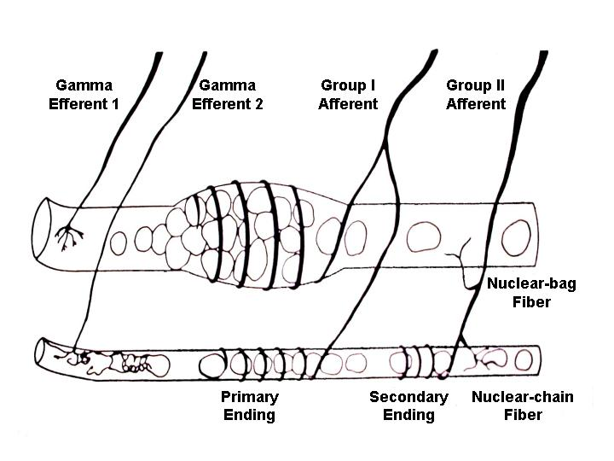

The spindle responds when it is stretched, by sending off a stream of pulses. As shown in Figure 5, the primary endings alert the nervous system that a stretch is occurring, whereas the secondary endings indicate a fair approximation of actual amount or objective measure of stretch of the muscle (Bradley, 1981).

Figure 5. Muscle Spindle Output
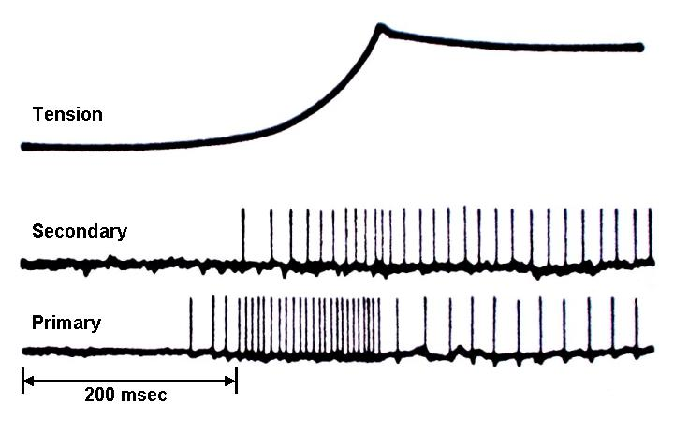

This has important implications in dentistry. When the mouth is opened wide for dental work, the spindles within the masticatory or jaw-closing muscles stretch, sending output down the afferent fibers, which synapse with the alpha motor neuron of the muscle. Thus the muscle tightens up and attempts to return to its original length (Bradley, 1981). Therefore, the jaw muscles become very tight on wide openings. This in turns loads the temporo-mandibular joint and can damage the cartilage, or inter-articular disc in the joint and cause TMJ dysfunction. To make matters worse from a dental perspective, the gamma efferent fibers receive input from the basal ganglia. The basal ganglia are a set of structures that surround the limbic system. They are involved with integrating feelings, thoughts and movement and help to smooth motor behavior. The basal ganglia regulate the body’s “idle speed”, affecting anxiety level (Amen, 1998, p. 43).

So how does this all tie together? When we are relaxed, we have a small space of 1 to 3 mm between our teeth when we are sitting or standing. When we get anxious or scared, the basal ganglia sends output to the gamma efferent neurons, which in turn make the spindle “hyper-sensitive.” A hyper-sensitive spindle behaves as if the spindle is stretched, and before we realize it, we are clenching our teeth (watch the coaches and general managers during sporting events. Not only are they often clenching, but they have large, well developed masseter muscles seen as large lumps on the sides of their face). The basal ganglia/spindle mechanism causes severe jaw tension in patients who are scared when visiting a dentist, which in turn can damage the temporo-mandibular joint, leading to a lifetime of jaw and facial pain.

Now here’s the critical study. In this simple jaw-open study, six participants were asked to open their mouth near maximal openings to activate muscle spindles within the masseter muscle. The participants indicated that they had no reasons to be anxious during this study, so activation of the basal ganglia should not have been a confounding factor. The participants served as their own controls. EMG activity involving primarily fast-twitch muscle (100-300 Hz), and TMJ symptoms such as muscle soreness, stiffness of jaw and TMJ clicking sounds, was collected on the left masseter muscle during wide opening on both trials. The following day, the exercise was repeated during 10 Hz AVE from a DAVID Paradise. The results show a marked reduction in muscle tension and symptoms of TMJ dysfunction in the AVE trial. Figure 6 shows the EMG results of the study.

Figure 6. Masseter Muscle Tension during Wide Mandibular Opening

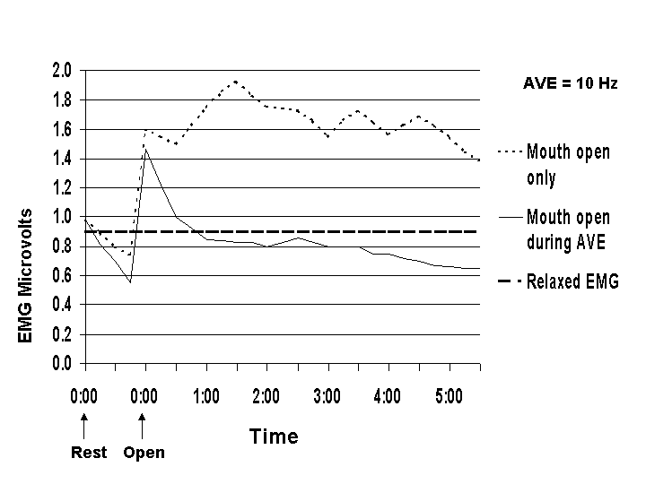

Conclusion

A great deal of TMJ and MPD symptoms are directly related to stress, fear and anxiety. Both meditation and AVE have been shown to effectively reduce these symptoms. Furthermore, AVE may also de-activate muscle spindle tone and the resulting muscle tension through two processes: 1) calming related basal ganglia activity, and 2) de-activating the reflex loop that controls muscle tone in relation to muscle stretch.

Footnote:

1. For more information, address all correspondence to:
David Siever, c/o Mind Alive Inc., 9008 - 51 Avenue, Edmonton, Alberta, Canada, T6E 5X4 Toll Free: (800) 661-6463 Fax: 780-461-9551
Web: www.mindalive.com Email: info@mindalive.com
References:

Amen, D. (1998). Change your brain, change your life. New York: Three Rivers Press.

Anderson, D. (1989). The treatment of migraine with variable frequency photic stimulation. Headache, 29, 154-155.

Bradley, R. (1981). Basic oral physiology. Chicago & London: Year Book Medical Publishers.

Christensen, L.V. (1981). Jaw muscle fatigue and pains induced by experimental tooth clenching: A Review. Journal of Oral Rehabilitation, 8, 27-36.

Corah, N. & Pantera, R. (1968). Controlled study of psychologic stress in a dental procedure. Journal of Dental Research, 47, 154-157.

Dewitt, C. (1966). An investigation of psychological and behavioral responses to dental extraction in children. Journal of Dental Research, 45, 1637-1651.

Eppley, K. & Abrams, A. (1989). Differential effects of relaxation techniques on trait anxiety: A meta-analysis. Journal of Clinical Physiology, November, Vol 5, No 6, 957-973.

Gardner, W. & Licklider, J. (1959). Auditory analgesia in dental operations. Journal of the American Dental Association, 59, 1144-1149.

Gardner, W., Licklider, J. & Weisz, A. (1960). Suppression of pain by sound, Science, 132, 32.

Giddon, D. (1966). Psychophysiology of the oral cavity. Journal of Dental Research, Supplement to No. 6., 1627-1636.

Kroger, W. S. & Schneider, S. A. (1959). An electronic aid for hypnotic induction: A preliminary report. International Journal of Clinical and Experimental Hypnosis, 7, 93-98.

Laskin, D. (1969). Etiology. of the pain-dysfunction syndrome. Journal of the American Dental Association. 79, 147.

Lazarus, R. (1966). Some principles of psychological stress and their relation to dentistry. Journal of Dental Research, 45, 1620-1626.

Manns, A., Miralles, R., & Adrian, H. (1981). The application of audiostimulation and electromyographic biofeedback to bruxism and myofascial pain-dysfunction syndrome. Oral Surgery, 52 (3), 247-252.

Margolis, B. (1966, June). A technique for rapidly inducing hypnosis. CAL (Certified Akers Laboratories), 21-24.

McClintic, J. (1978). Physiology of the human body. New York: John Wiley & Sons.

Monsey, H. (1960). Preliminary report of the clinical efficacy of audio-analgesia. Journal of the California Dental Association, 36, 432-437.

Morosko, T. & Simmons, F. (1966). The effect of audio-analgesia on pain threshold and pain tolerance. Journal of Dental Research, 45, 1608-1617.

Morse, D. & Chow, E. (1993). The Effect of the RelaxodontTM brain wave synchronizer on endodontic anxiety: Evaluation by galvanic skin resistance, pulse rate, physical reactions, and questionnaire responses. International Journal of Psychosomatics, 40 (1-4), 68-76.

Moulton, R. (1966). Emotional factors in non-organic temporomandibular pain. Dental Clinics of North America, 10, 609.

Rugh, J. & Solberg, W. (1975). Electromyographic studies of bruxist behavior, before and during treatment. Journal of California Dental Association, 3, 56-69.

Sadove, M. S. (1963, July). Hypnosis in anaesthesiology. Illinois Medical Journal, 39-42.

Schermer, R. (1960). Analgesia using the “Steregesic Portable”. Military Medicine, 125, 843-848.

Sidney, B. (1960). Audio-analgesia in pediatric practice: a preliminary study. Journal of the American Pediatric Association, 7, 503-504.

Siever, D. (1992). Tension occurring in muscles of mastication during jaw opening. Unpublished manuscript.

Spielberger, C., Gorsuch, R. & Lushene, R. (1970). Manual for state-trait anxiety inventory. Consulting Psychologists Press. Palo Alto, CA.

Thomas, N., Siever, D. (1989). The effect of repetitive audio/visual stimulation on skeletomotor and vasomotor activity, 238-245. In Waxman, D., Pederson, D., Wilkie, I., & Meller, P. (Eds.) Hypnosis: 4th European Congress at Oxford. Whurr Publishers, London.

Weinstein, P., Smith, T. & Packer, M. (1971). Method for evaluating patient anxiety and the interpersonal effectiveness of dental personnel: An exploratory study. Journal of Dental Research, 50 (5), 1324-1326.

Williams, P., West, M. (1975). EEG responses to photic stimulation in persons experienced at meditation. Electroencephalograpy and Clinical Neurophysiology, 39, 519-522.

Yemm, R. (1969). Variations in the electrical activity of the human masseter muscle occuring in association with emotional stress. Archives of Oral Biology, 14, 873-878.

Yemm, R. (1971). Comparison of the activity of left and right masseter muscles of normal individuals and patients with mandibular dysfunction during experimental stress. Journal of Dental Restoration, 50, 1320.

